2. Data Collection Process - DDoS Threat Intelligence

2.1. Purpose
The purpose of this stage is to collect publicly available information related to DDoS threats and transform it into structured threat intelligence data.
The project will focus on collecting information about:
- Suspicious IP addresses;
- Domains and hostnames;
- Network infrastructure;
- Autonomous System Numbers (ASN);
- Open network services;
- Historical DNS information;
- Relationships between IP addresses and domains;
- Threat reports and reputation information.
The collected information will be used to identify relationships between different infrastructure elements and create a dataset for further analysis.

2.2. Open Source vs. Closed Source Data

Open-source data
Open-source intelligence (OSINT) is information that can be legally obtained from publicly accessible sources.
For this project, examples include:
- Public threat intelligence databases;
- VirusTotal public reports;
- Shodan information about publicly indexed hosts;
- DNS records;
- WHOIS information;
- Public security reports;
- Public malware and threat reports;
- Security researchers' publications.
OSINT is useful because the information can be collected without direct access to the infrastructure being investigated.
For example, VirusTotal allows users to search for IP addresses, domains, URLs and file hashes and retrieve information associated with them.
Maltego can also combine information from public sources and visualize relationships between domains, IP addresses, DNS names and other entities.

Closed-source data
Closed-source data requires access to private or restricted information.
Examples include:
- ISP network logs;
- firewall logs;
- Internal SIEM data;
- NetFlow records;
- IDS/IPS alerts;
- Private threat intelligence feeds;
- DDoS mitigation provider telemetry;
- Internal incident reports.
This type of data can provide much more detailed information about an actual attack, but it is normally unavailable to an external researcher.

Comparison
Feature | Open Source | Closed Source
Accessibility | Public | Restricted
Example | VirusTotal | ISP logs
Cost | Often free/limited | Usually requires access
Privacy | Public information | Potentially sensitive
Data volume | Variable | Potentially very high
Use in our project | Yes | No
Main purpose | External threat intelligence | Internal incident analysis
Therefore, our project will primarily use open-source data, because the objective is to demonstrate an OSINT-based DDoS threat intelligence workflow.

2.3. Data Sources
The project will use three main tools required by the assignment:

1. Shodan
Shodan can provide information about Internet-facing infrastructure.
For our project, we can collect:
- IP address;
- Open ports;
- Detected services;
- Hostnames;
- Organization;
- ASN;
- Geographic information;
- Service banners.
Shodan can also be used through Maltego to find domains associated with an IP address or IP addresses associated with hostnames.
Purpose in our project:
Identify publicly visible network infrastructure that may be relevant to the investigation.
Important: we should only collect information passively and should not perform attacks, stress tests, or unauthorized scanning against third-party systems.

2. VirusTotal
VirusTotal will be used to enrich the information collected from other sources.
It supports searches for:
- IP addresses;
- Domains;
- URLs;
- File hashes;
- Comments and related objects.
For an IP address, VirusTotal can provide information such as:
- ASN;
- AS owner;
- Geographical information;
- Reputation/detections;
- Related domains;
- relationships with other objects.
The VirusTotal API also provides a dedicated IP-address report endpoint.
Purpose in our project:
Check whether collected infrastructure has existing threat intelligence or reputation information.

3. Maltego
Maltego will be used to connect the information collected from different sources.
For example:
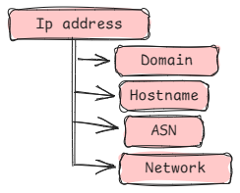
Maltego is particularly useful because it represents relationships visually. Its standard transforms can investigate infrastructure by starting from a domain, IP, DNS name or website and discovering related entities.
For example:
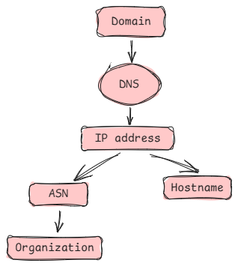
This makes it easier to identify connections that may not be obvious when looking at individual records.

